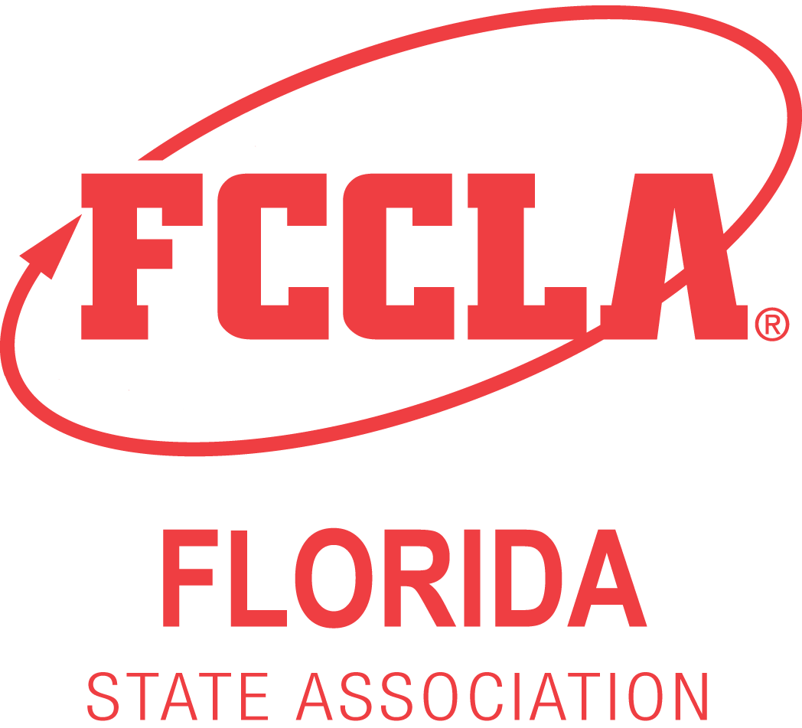

2022 State Leadership Conference
STAR Events Online Orientation Documentation

Thank you for completing the STAR Event participant online orientation for the 2022 State Leadership Conference. To receive the 2 points for completion on the STAR Events Point Summary Form, print this page and have your adviser verify by signing and dating below. Bring this signed form with you when you compete, and submit it to your event Room Consultant at the time of your event presentation.
Chapter Name: _______________________________________
Name of Event: _______________________________________________________________
Category (Level 1, Level2, Level 3):______________________________________________________
Participant Name(s):
1)__________________________________________________________
2)__________________________________________________________
3)__________________________________________________________
4)__________________________________________________________
5)__________________________________________________________
6)__________________________________________________________
7)__________________________________________________________
8)__________________________________________________________
I verify that the participants listed above have viewed the STAR Event Online Orientation video and related materials available on the FCCLA website.
Chapter Adviser Signature: ____________________________________________________
Date Orientation Completed ____________________________________________________
Submit this form to the Room Consultant at the time of your event presentation.

DO NOT TURN IN AT REGISTRATION PICKUP OR FAX TO THE STATE OFFICE!
Only one form per entry (team or individual participant) is required.

